PUMA Releases MANCHESTER CITY Home Shirt For The Season

**Introduction to the history of Manchester City Club**

Manchester City Football Club is a professional football club based in Manchester, England. Up to now, Manchester City has won 7 times English football, 6 times won the FA Cup, 8 times won the English Football League Cup, 6 times won the English Super Cup and 1 time won the European Cup. .

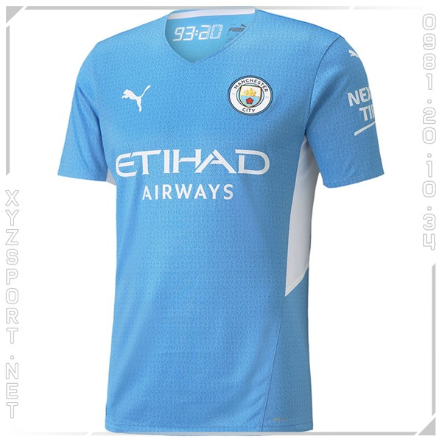

The Man City shirt is painted in light blue and white, with a digital pattern applied.

The collar is V-shaped, with a stamp inside that combines the minute that Agüero scored the winning goal in the 2011/12 title and the number 10 for the years to be commemorated (and the number that Kun had for many years).

The club's logo has its official colors, while the logos of technical sponsors and Etihad Airways are painted white for the first time in years. Light blue shorts, like those from 10 years ago, and ankle socks complete the Citizen's uniform.